BPP Business School
Coursework Cover Sheet
Module Name | BSc Accounting and Finance
Student Reference Number
(SRN)
Assessment Title | Digital Behaviours

Please complete the yellow sections in the below declaration:
Declaration of Original Work:
I hereby declare that I have read and understood BPP’s regulations on plagiarism and that this is my original work, researched, undertaken, completed and submitted in accordance with the requirements of BPP School of Business and Technology.
The word count, excluding contents table, bibliography and appendices, is ______ words.
Student Reference Number: __________ Date: ______

By submitting this coursework you agree to all rules and regulations of BPP regarding assessments and awards for programmes.
Please note that by submitting this assessment you are declaring that you are fit to sit this assessment.
BPP University reserves the right to use all submitted work for educational purposes and may request that work be published for a wider audience.

Executive Summary
The development of digital behaviours in their workforce, such as technical proficiency, problem-solving, ability to communicate, creativity, flexibility, teamwork, and dedication to excellence, is a top priority for Google. The firm has been able to keep its status as a top IT firm because of its commitment to lifelong learning and growth. Although Google's strategy has both advantages and disadvantages, its emphasis on online behaviours has helped to promote an innovative and forward-thinking culture.
Table of Contents
Introduction 1
Task-1: 1
Skills and Behaviours: 1
Task-2: 2
Strengths and weaknesses: 2
Task-3 3
Risk and opportunities faced by Google Company. 3
Conclusion 5
References 6

Introduction
The acts, interactions, and activities people engage in when using digital technology like tablets, computers, cellphones, and the internet are referred to as digital behaviour. It includes a broad range of activities, such as social media use, online shopping, online gaming, and online communication. The present report will highlight the digital behaviours of Google Company, a leading technology company operating in more than 219 territories in the world.
Figure 1 Google Logo
(Source: Aja Frost, 2019)

Task-1:

Skills and Behaviours:
Google is renowned for its inventive culture, flexible workplace, and relentless pursuit of improvement. Employees need a variety of digital skills, attitudes, and behaviours that support Google’s values and mission in order to succeed in the company’s workplace (Bergdahl et. al. 2020). Technical proficiency is a crucial digital talent that is required at Google. The ability to grasp programming languages, data analysis, and software development is required of all employees. Employees who can swiftly adjust to new situations and pick up new technologies are highly rewarded at Google, which promotes constant learning.
Problem-solving is another crucial digital ability. Employees at Google must be capable of promptly and effectively identifying and resolving complicated technological issues because of the firm’s enormous scale. Collaboration, technical expertise, and critical thinking are all necessary for this (van Laar et. al. 2019). At Google, communication skills are equally crucial. Employees must be able to explain technical concepts and ideas to a variety of audiences, including non-technical stakeholders and other technical professionals. To ensure that teams work together fluidly and every team member is working towards the same objective, effective communication is essential.
Professionals at Google must have an attitude with is open to fresh ideas and risk-taking, as both of these are values that the company strongly values. In addition to a willingness to try new things and learn from mistakes, this calls for an approach of constant progress. Along with having the necessary digital abilities, success at Google also heavily weighs traits and behaviours including adaptability, teamwork, and a dedication to excellence (Esteve-Mon et. al. 2020). The organisation values people who can adapt to new situations and work productively in them, as well as those who can work well with others and consistently aim for excellence.

Task-2:

Strengths and weaknesses:
It is widely acknowledged as one of the most successful and creative approaches in the tech sector for Google to train its workers in digital competencies, attitudes, and behaviours. It has some advantages and disadvantages, though, just like every strategy.
Strengths:
The focus on ongoing education and professional growth in Google’s strategy is one of its major advantages. The business provides a variety of training and development options, such as seminars, workshops, and online tools, to aid employees in gaining new skills and staying current with the newest trends and innovations (Rodrigues et. al. 2022). Google has been able to keep up its status as a pioneer in the IT sector because of its dedication to lifelong learning.
Emphasising creativity and innovation in Google's strategy is another asset. Google promotes unconventional thinking and taking chances among its staff. Some of the most cutting-edge products produces by the firm, such as Gmail and Google Maps, were developed as a result of the well-known “20% time” policy, which enables workers to spend 20% of their working time on personal projects (Kishor, 2022). Google has been able to keep its rank as a leader in the tech sector because of this strategy.
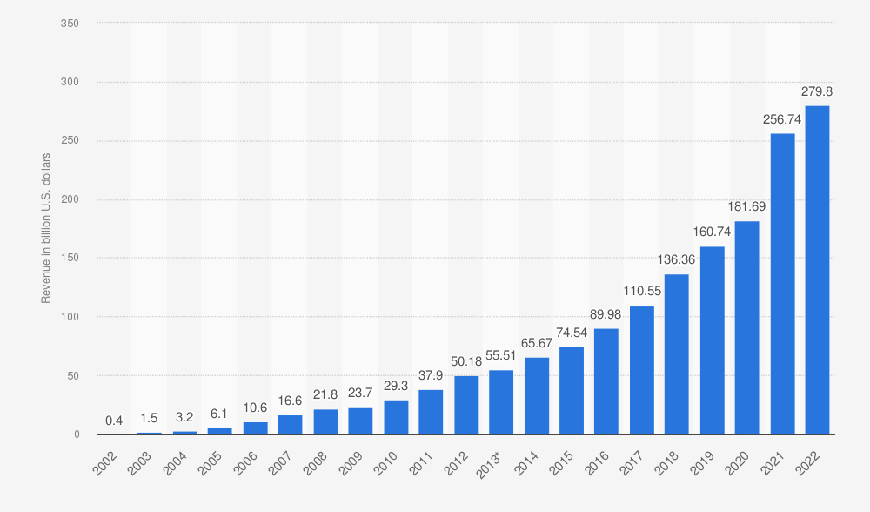
Figure 2 Current Revenue of Google
(Source: Tiago Bianchi, 2023)
Weaknesses:
The company’s emphasis on technical talents at the cost of soft skills is one area of potential vulnerability. Along with technical knowledge, soft skills like teamwork and communication are essential for success in the job (Fasoli, 2021). Since these skills are frequently connected with historically underrepresented groups, some opponents have said that Google's concentration on technical talent has resulted in a lack of diversity and inclusion inside the corporation.
The firm’s dependence on a highly competitive workplace is another possible weakness of Google's strategy. Even though it may be a great motivator, competition can also cause burnout and a lack of work-life balance. The company's demands have reportedly put pressure on certain employees to put in long hours and compromise their personal life.

Task-3:

Risk and opportunities faced by Google Company.
The digital skills, attitude, and behaviour of Google's workers provide both challenges and possibilities as one of the leading technology businesses in the world. The fast speed of technological advancement and the potential for being left behind the competition are two of the biggest risk faced by Google Company (Guillén-Gámez et. al. 2021). The company needs to make investments in the advancement of its workers' digital abilities, including technical expertise in new technologies, data analysis, and programme, to remain competitive. The potential risk can cause an impact on staff depression and mental health problems are another risk for the Company. The demanding workplace and long workweeks in the technology sector can cause depression and mental health issues which may reduce employee retention and performance. On the other hand, Google also has opportunities in the field of digital skills, attitudes, and behaviours. By providing chances for professional growth and training the firm may use its position as a leader in technology to draw in and keep top people.
This can help staff to develop their abilities and stay up-to-date with developing digital trends. The firm can also benefit from the development of flexible work schedules, and remote work, which can enhance job satisfaction and the work-life balance of employees (Rosenbusch, 2020). Increased productivity and employee engagement as well as lower turnover rates can result from this. Another opportunity for the Company in terms of attitudes and behaviours is to encourage a culture of innovation and creativity which may benefit the creation of new products. This will also help the company in remaining competitive in the market. A culture of innovation and continuous improvement may be established by motivating people to think creatively while taking calculated risks.
From the above discussion of risks and opportunities of Google Company it is clear that Google must be aware of the advantages and disadvantages of its workforce's use of digital skills, attitudes, and behaviours (López et. al. 2019). The business may set itself up for long-term success in the quickly evolving technology sector by making investments in staff development and fostering a healthy culture.

Conclusion
In conclusion of this report, Google focuses a high priority on helping its employees grow their digital abilities, attitudes, behaviours. This strategy is based on dedication to excellence, problem-solving, innovation, communication, teamwork, and continual learning and development. Although this strategy has both advantages and disadvantages, it has helped Google maintain its position in the market. Lastly, this report discussed the risks and opportunities faced by the organisation in the areas of digital skills and behaviours.

References
Bergdahl, N., Nouri, J. and Fors, U., (2020). Disengagement, engagement and digital skills in technology-enhanced learning. Education and information technologies, 25, pp.957-983.
Esteve-Mon, F., Llopis, M. and Adell-Segura, J., (2020). Digital competence and computational thinking of student teachers. International Journal of Emerging Technologies in Learning (iJET), 15(2), pp.29-41.
Fasoli, M., (2021). The overuse of digital technologies: human weaknesses, design strategies and ethical concerns. Philosophy & Technology, 34(4), pp.1409-1427.
Guillén-Gámez, F.D., Mayorga-Fernández, M.J., Bravo-Agapito, J. and Escribano-Ortiz, D., (2021). Analysis of teachers’ pedagogical digital competence: Identification of factors predicting their acquisition. Technology, Knowledge and Learning, 26, pp.481-498.
Kishor, J., (2022). Digital marketing modelling: A sustainable competitive advantage for SMEs. World Review of Entrepreneurship, Management and Sustainable Development, 18(4), pp.404-428.
López, I., Ibarra, E., Matallana, A., Andreu, J. and Kortabarria, I., (2019). Next generation electric drives for HEV/EV propulsion systems: Technology, trends and challenges. Renewable and Sustainable Energy Reviews, 114, p.109336.
Rodrigues, M., FRANCO, M. and Silva, R., (2022). Digitalisation And Innovation In Smes: Influences On The Advantages Of Digital Entrepreneurship. International Journal of Innovation Management, 26(08), p.2250066.
Rosenbusch, K., (2020). Technology intervention: rethinking the role of education and faculty in the transformative digital environment. Advances in Developing Human Resources, 22(1), pp.87-101.
van Laar, E., van Deursen, A.J., van Dijk, J.A. and de Haan, J., (2019). Determinants of 21st-century digital skills: A large-scale survey among working professionals. Computers in human behavior, 100, pp.93-104.
Aja Frost, (2019). Google Logo. [Online] (Accessed through): https://blog.hubspot.com/marketing/google-logo-history (Accessed on 8th April, 2023).
Tiago Bianchi, (2023). Current Revenue of Google. [Online] (Accessed through): https://www.statista.com/statistics/266206/googles-annual-global-revenue/ (Accessed on 8th April, 2023).

