Submitted To : Ma’am Kiran Sehar

Submitted By:
Kinza Tariq (20-UON-0790) Minahil Asghar (20-UON-0787) Iram Arif (20-UON-0788)
Khadija Sultan (20-UON-0807)
Raja Sham (20-UON-0826)
Tayyab Raza (20-UON-0793)
Abdul Razzaq (20-UON 0798)
Course Title: Energy And Environment
Department: Environmental Science
Semester: BS 7th (Morning)

Topic: Environment and Transportation Environment:
The surroundings or conditions in which a person, animal, or plant lives or operates.

Transportation:

Transport or transportation is the intentional movement of humans, animals, and goods from one location to another.
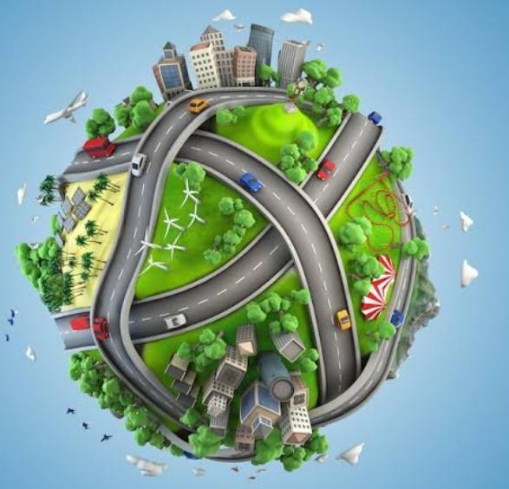

Relationship Between Environment and Transportation

Transport activities contribute at different geographical scales to environmental problems ranging from local ( noise and carbon monoxide emissions) to global ( climate change).
The relationship between transport and environment is paradox in nature. From one perspective transportation is categorized in two areas, passenger transportation which consists of all transport of individual, refers to all forms of public and private transport of commuters, passenger baggage transport whether scheduled or unscheduled.
The second category of transportation is freight movements meaning the movement of raw materials, of work in progress, finished goods from supplier to consumer and of returns of used and new products back to supplier. Freight movement is also consists of movement of agricultural products (food, fertilizers) and animals.
Transportation causes a considerable amount of harmful emissions, which causes problems that become harmful and costly to the society and environment. Based on different mode of transport which includes air cargo, shipping, rail, trucking, pipelines and intermodal terminals, the effects on the environment are majorly air pollution, water pollution, noise, global climate concerns, accidents, land take and habitat fragmentation both for humans and animals.

The Evolution of transportation And Its Effect On Environment Throughout History

Transportation began when humans gained the ability to walk, this then lead to the invention of secondary transportation methods that did not involve having to physically move and walk on one’s feet to get somewhere. These accompanying creations to walking started with the oldest canoe (8000B.C) being discovered in Holland. followed by the wagon created during 3000B.C, later being replicated in the 1700’s. Not only were wagons invented in the 1700’s but boats were too.

In the early 1800’s the first train and steam engine took off, soon after came the first bike, then the first passenger train, followed by the first passenger ship. In the late 1800’s the first electricity-
In the early 1900’s the first ever gasoline-powered plane was created by the Wright brothers and was able to take off and land with zero damage. Next came the fuel-powered 4 wheeled car, named “Model T” created by Henry Ford. After Model T, the first passenger airplane took off followed by upgrades made to current existing creations up until now. New bikes for different uses (mountain, street bike etc.), Larger, more efficient trains and railways (for both, human and cargo transport), high quality, diversified water transportations (luxury ships, yachts, speed boats etc.) and so on.

Basics Of Industrial Revolution

Up until the industrial revolution, water was the main power source. However, what boosted the economic growth around the world was the combined use of both coal and water (steam) to power engines. These stable sources ensured the possibility of higher industrial productivity. Oil and natural gas were later introduced and further used in the manufacturing industry (cars, ships, planes, cooling technologies etc.

The industrial revolution introduced easy means of movement transportation due to the availability of fuel sources that power them. However, these comfortable, accessible means were accompanied by negative impacts on the environment. These effects include noise pollution, air pollution, acidification and emission of greenhouse gases . In the past (pre- industrial revolution), transportation used to run either manually or by electricity and its availability was much less than what it was since the industrial revolution. This meant that there were no harmful emissions being released since there was nothing to burn off in the first place. Now that lots of fuel is being burnt off through engines and large populations now having access to such fuel dependent means, the risk of harm is much greater.

Impacts of Transportation on Environment Air pollution:
Air pollution is considerably seen has the most dangerous environmental threat caused by transportation. Highway vehicles , marine engines , locomotive , and aircraft are the main causes of pollutant which affects air quality causing damage to human health and the climatic changes in the environmental system, all these includes gas and emissions that are particulate matters. All these toxic air pollutant are closely related with the cause of cancer, cardiovascular (heart arteries, capillaries and veins), respiratory and neurological diseases. Air pollution reduces the availability of oxygen which affects the blood stream, and can be extremely harmful to public health
If Carbon Monoxide (CO) is inhaled; also nitrogen dioxide (NO2) emission from different modes of transportation when inhaled reduces lung function, affects the respiratory immune defense system and put humans at higher risk of respiratory problems. Acid rain is caused by the emission of Sulphur dioxide (SO2) and nitrogen oxide in the atmosphere from different acid compounds that when they get mixed in the cloud water. Acid rain has serious disruption on the built environment, limits agricultural crop yields and causes deforestation. Acid rain also causes smog, affecting the visibility in the environment having adverse effect on the quality of life and less attraction of tourist activities.

Water pollution:

Generally most of the other mode of transportation does not really have effect on water quality, except for shipping and in land water ways transport, and also in times of accidents i.e. pipeline bursting, car accident entering the waters, oil spill etc. The activities of shipping are increasing because of the increase in demand for shipping. Emissions from marine transport as also increased as well; the main effects of marine transport on water subsequently arise from dredging, waste disposal, ballast waters and oil spills. Dredging is essential to build and maintain water depth for ease of shipping operations and port accessibility. Dredging affects the marine biological diversity.

Waste disposal of plastics at sea is a major source of environmental harm, since the material are both sizeable and persistent .Road transportation is usually not a factor to consider when it comes to water pollution, but issues like road accidents and vehicle exhaust are both sources of oil and

hazardous chemicals which run off the road into surface and ground by rain waters, into seas and ocean these are all direct and indirect causes of water pollution.

Noise Pollution:

Noise pollution refers to the unpleasant irregular and chaotic sounds. It traumatizes the hearing organ, it’s unpleasant and disturbing character are serious threat to the quality of life, noise contributes to such health problems that affects the quality of life such as stress, sleep disturbances, cardio vascular disease, and hearing loss. And also long term exposure to noise levels greater than 75db seriously hampers hearing and has a significant discomfort to human physical and psychological existence.

- Trucking:

There is different size of trucks causing noise pollution at different scale. Trucks are considered to be a more significant source of noise than other modes of transport.
- Rail:

Rail movement is a lesser noise pollutant when compared to trucks.

- Air Transport:

People living or working around airports suffer from major nuisance from the noise pollution generated during landing and taking off of planes, traffic congestion and other dangers of air crashes. It is a major nuisance to those who live or work in the vicinity of airport.

Climatic change

All the activities from different mode of transport industry have lead to the emission of several million tons of gases into the atmosphere every year. Gasses, dusts from contact from road and tire

cohesion and ash like substances from different modes of transport like lead ,carbon monoxide , carbon dioxide ,methane , nitrous oxide ,chlorofluorocarbons , nitrogen oxides, benzene and volatile components ,heavy metals and particulate matters as lead to climatic change when mix in the cloud waters.

Land take and soil quality

- The construction of transportation infrastructures and facilities has an impact on the layer of urban landscape. The construction of roads, airport, and rail ways take up significant land space in the environment, in most cases displacing people of their habitat and farm land.
- Airport takes up space, and discourages people from living in areas close to the airport.
- Water transport displaces some organism from their habitat, and also dredging is bad for the water and soil organism. Dredging causes soil around the water to be contaminated.

Environmental Benefits Of Sustainable transport

Sustainable transport essentially refers to low- and zero-emission modes of transport that are energy-efficient, accessible, and affordable. Sustainable transport is important because it contributes to the reduction of damaging carbon dioxide emissions which directly benefit the environment, further decreasing atmospheric pollution and improving air quality in cities.
Sustainable transportation is a means of travel that is safe and has little impact on the environment. Sustainable transportation is often referred to as "green transportation." Sustainable transportation has numerous benefits, including reducing your carbon footprint, enhancing your health, and saving money by using sustainable transportation. Sustainable transportation promotes justice

within and between future generations by ensuring that people, companies, and society's basic access and development needs are met safely and in a sustainable way for both human and environmental health.
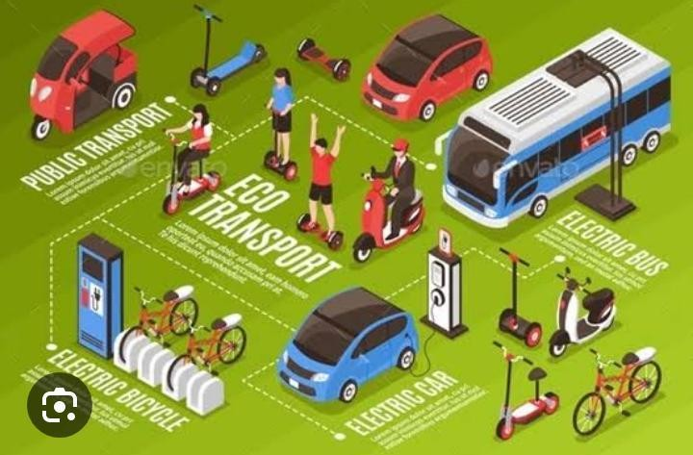

Reduces carbon footprint:

Sustainable transportation like cycling and walking has almost no carbon emissions. They don't use energy, make greenhouse emissions, contribute to air pollution, or make noise. Additionally, by reducing the volume of vehicles on the road, public transit produces fewer emissions per passenger mile than single-occupancy vehicles.

Reduces congestion:

When more people start switching to sustainable transportation, there will be less congestion and traffic on the roads. Less traffic will allow people to reach their destination on time, and more open spaces and roads will help protect our natural habitat.

Good for public health:

One major benefit of sustainable transportation is that it can improve the public's general health. Cycling and walking can help you improve your overall health as well.

Pocket-friendly:

Opting for sustainable transportation is a great way to save transportation costs. Taking public transport to work is less expensive than maintaining and fueling a personal vehicle. Cities may reduce maintenance costs for roads and parking lots.

Reduces noise pollution:

Less road congestion means less noise and better living conditions for people .We rarely think of noise pollution when it comes to cars, that is unless you live by a busy street. Less driving will make your neighborhood quieter to everyone's benefit.

Healthier Communities

Improved air quality in a community means greater health benefits for the people who live there. That can mean fewer cases of respiratory ailments such as asthma and even cancer. People are also more prone to get out and exercise when the air quality is better.

Harmful Chemicals Are Reduced
We usually think of gas as the only pollutant when it comes to cars, but they also use antifreeze and other fluids that are bad for the environment. Taking sustainable transportation instead of driving cuts down on all of them.

Fewer Cars Equal Fewer Roads
More cars mean more roads need to be built, which causes water run-off that contributes to ground and water pollution. Fewer cars in favor of active transportation such as bikes mean more bike paths and lanes which are more sustainable.

Less Pollution
Every vehicle on the road releases an average of one pound of CO2 per mile driven. Compared with driving alone, taking public transportation reduces CO2 emissions by 45%, decreasing pollutants in the atmosphere and improving air quality.

