[To be executed on Stamp Paper]

Sale Deed

Dated: [●], 2023

Between

Imperium Hospitality (Private) Limited
(the Seller)

&

Fauji Fertilizer Company Limited
(the Buyer)

Sale Deed

This Sale Deed (this “Sale Deed”) is made at Lahore on this [●] day of [●] 2023 (the “Signing Date”),

by and between

Imperium Hospitality (Private) Limited, a company incorporated under the laws of the Islamic Republic of Pakistan with its registered office located at 10-Q, Gulberg II, Lahore, Pakistan through its Chief Executive Officer, Mr. Sheraz Jehangir Monnoo, holding CNIC No: 35202-2479922-7 (hereinafter referred to as the “Seller”, which expression shall, where the context so permits, mean and include its successors-in-interest and permitted assigns);

And

Fauji Fertilizer Company Limited, a company incorporated under the laws of the Islamic Republic of Pakistan with its registered office located at Sona Tower, 156, The Mall, Rawalpindi, Pakistan through its authorized representative, Senior Manager (CSR&CW) Brig. Muhammad Arif (Retd.), holding CNIC No. 61101-4127358-5 (hereinafter referred to as the “Buyer”, which expression shall, where the context so permits, mean and include its successors-in-interest and permitted assigns),

(the Buyer and the Seller are hereinafter collectively referred to as the ‘Parties’ and each individually as a ‘Party’).

Recitals

- Whereas, the Seller is the lawful and absolute, legal and beneficial freehold owner in possession of all that piece and parcel of land measuring approximately 7.51 Kanals situated at 1 - H, Gulberg II, Lahore, more particularly described in Annexure A (Description of Property) (the “Property”) through sale deed dated February 8, 2017, registered vide Document No. 435, Volume No. 714 on February 16, 2017 in the office of the Sub-registrar Gulberg Town, Lahore (the “Original Sale Deed”);

- Whereas, the Seller is developing a multi-story office building tower on the Property namely “1-H Gulberg” which will cover approximately --------------- gross square feet from the ground floor and above with approximately ---------------- gross square feet of basement area (the “Project”);

- Whereas, the Parties have entered into a Memorandum of Understanding dated November 15, 2019 (“MOU”) and an Agreement to Sell dated 24 February 2020 (as amended through Amendment Agreement dated 15 June 2021 and Amendment Agreement No. 2 dated [insert] (the Agreement to Sell, Amendment Agreement and the Amendment Agreement No. 2 shall collectively be referred to as the “Agreement to Sell”)) and are now entering into this Sale Deed to record the terms of the post-development sale by the Seller to the Buyer of the building constructed by the Seller (measuring approximately 157,656 gross square feet area from the ground floor and above in accordance with the specifications and design requirements more particularly described in Annexure B (Description of the Building Tower - Block A)) (the “Building Tower – Block A”) facing Jail Road, Lahore and forming part of the intended Project along with all rights, title and interests therein, including proportionate interest of [insert] percent in the Property (the “Sale Property”);

- Whereas, the Seller is allocating the right to use to the Buyer of: (1) specified common areas of the Project that are situated within the Building Tower – Block A, more fully described in Annexure D (List of Common Areas) (“Common Areas”); and (2) car parking slots for one hundred and forty (140) cars, with one hundred and twenty (120) car parking slots allocated in the basement area (49 car parking slots in basement No. 1, 49 car parking slots in basement No. 2 and 11 mechanical car parking slots equal to 22 car parking slots in basement No. 3) and twenty (20) car parking slot allocated on ground floor of the Project, more fully described in Annexure E (Car Parking Schedule) (“Allotted Car Parking”);

- Whereas, the Buyer is desirous of purchasing the Sale Property from the Seller on such terms and conditions as stipulated under this Sale Deed;

(d) Whereas, the Buyer has simultaneously with the execution of this Sale Deed entered into a management agreement dated [insert] with the Seller (the “Management Agreement”), governing all matters relating to the maintenance and management of the specified areas of Building Tower - Block A, Common Areas and Allotted Car Parking.

Now, therefore, in view of the foregoing and in consideration of the mutual benefits to be derived and the representations and warranties, covenants and agreements contained herein and other good and valuable consideration, the sufficiency of which is hereby acknowledged and intended to be legally binding, the Parties hereby agree and this Sale Deed witnesses as follows:

- The Seller hereby sells, transfers, assigns and conveys to the Buyer the Sale Property along with all of the Seller’s legal and beneficial rights, title and interest in the Sale Property (including all rights, easements and benefits, free and clear of any and all charges, liens, mortgages, claims, assignment or other kinds of encumbrances of whatsoever nature) (the “Encumbrances”) but subject to the Common Areas, common right of way and other common easements, more particularly described in Annexure B (Description of the Building Tower - Block A) for a total consideration of PKR 3,532,398,934/- (Pakistani Rupees Three Billion Five Hundred Thirty Two Million Three Hundred Ninety Eight Thousand Nine Hundred and Thirty Four only) (the “Sale Price”).

Nothing herein shall confer or be deemed to have conferred upon the Buyer any exclusive right, ownership or title to the Common Areas, common right of way and other common easements and Allotted Car Parking.

- In terms of the Agreement to Sell the Buyer has already paid the Seller a sum of the PKR [please insert] (Pakistani Rupees [please insert] only) out of the total Sale Price (as detailed in Annexure C (Details of Sale Price)), receipt of which the Seller hereby acknowledges.

- The remaining balance amount of the Sale Price, i.e., the sum of PKR [please insert] (Pakistani Rupees [please insert] only) has been paid by the Buyer to the Seller on the Signing Date of this Sale Deed, vide [Cheque No. / Pay Order No. [●], dated [●], drawn on [●]] in favour of the Seller, receipt of which the Seller hereby acknowledges and admits as the Sale Price.

- It is hereby confirmed by the Seller that on account of the aforesaid payments i.e., the Sale Price by the Buyer to the Seller, the Sale Price stands fully paid and no balance amount is remaining to be paid by the Buyer to the Seller on account of the sale of the Sale Property.

- The Seller has delivered the actual, physical, vacant, peaceful, and quiet possession of the Sale Property to the Buyer at the time of execution of this Sale Deed.

- For all intents and purposes hereof and subject to the applicable laws, the Seller hereby absolutely conveys actual, physical, vacant, peaceful and quiet possession of the Sale Property to the Buyer, to be dealt with in such manner as the Buyer may consider fit in the Buyer’s absolute discretion (subject to the terms and conditions of this Sale Deed and requirements of the Management Agreement).

- The Seller hereby warrants and represents that the Sale Property is free and clear from all Encumbrances whatsoever and that the Seller has full right, power and lawful authority to transfer, sell and convey all of its rights, title and interest to or in the Sale Property to the Buyer (including its proportionate interest of [insert] percent in the Property) along with the simultaneous allocation of the right to use the Common Areas and Allotted Car Parking. The Seller further represents and warrants that it has not done or caused or suffered to be done any act or deed whereby its right to transfer the Sale Property free and clear of all Encumbrances to the Buyer or grant of easement rights in relation to the Sale Property have been or may be impaired.

- The Seller hereby agrees to indemnify the Buyer against all claims, damages, losses, costs and charges, which the Buyer may suffer due to any defect in the title of the Seller in the Sale Property or due to any defect/error in the transfer of the Sale Property to the Buyer. In the event any defect arises in relation to the title of the Sale Property in the records of the relevant governmental authority, the Seller shall take all reasonable measures to promptly rectify such defect.

- The Buyer agrees to indemnify the Seller in the event of any penalty accruing to the Seller due to any negligence or wrongful or illegal act of the Buyer during the ownership of the Sale Property and/or use of the Building Tower - Block A, the Common Areas or the Allotted Car Parking.

- The Seller hereby covenants to pay all rents, rates, taxes, cesses, charges, surcharges and assessments, whatever payable in respect of the Sale Property up to the Signing Date of this Sale Deed. Furthermore, from the Signing Date of this Sale Deed, all the liabilities, obligations and responsibilities including all rents, rates, taxes, costs, charges, cesses, surcharges, assessments, etc., with respect to the Sale Property shall be borne by the Buyer and in case of the failure by the Buyer to do so, the Buyer shall indemnify and hold the Seller harmless against all penalties, damages, losses, costs, charges and expenses resulting from such failure and/or due to incorrectness of any representation, warranty, covenant, undertaking or document given by the Purchaser hereunder.

- The Seller has handed over the following documents at the time of execution of this Sale Deed:

- Non-Encumbrance Certificate issued by the Sub-registrar;

- Copy of the building approval letter along with plot amalgamation plan;

- Structure soundness certificate;

- Calibration certificates of all machinery/equipment;

- Test reports of steel, concrete and other materials; and

- A-1 Size of construction drawings i.e., structure, architecture, plumbing/drainage, fire alarm & fire fighting, electrical, HVAC and external development.

- The Seller hereby covenants with the Buyer that:

  - the Buyer shall (subject to the terms of this Sale Deed) be entitled at all times hereafter, to peacefully and quietly possess and enjoy the Sale Property in any manner as required by the Buyer and to receive the benefits thereof without any hindrance, interruption, claim or demand whatsoever from the Seller and/or any other person(s) claiming, whether in law or in equity, through or under it; and

  - the Seller and/or any person claiming, whether in law or in equity, through or under the Seller, any interest in the Sale Property or any part thereof, shall from time to time or at any time at the request of the Buyer do and execute or cause to be done and executed at the cost of the Buyer all such acts, deeds and things as may be necessary for properly and completely conveying, transferring and assuring to the Buyer all the rights, title and interest of the Seller in or to the Sale Property.

- The Seller shall execute all such documents and take every other reasonable action as necessary or required by the Buyer so as to completely and/or more perfectly and effectively secure assign, transfer and convey the Sale Property to the Buyer and shall sign all necessary documents/applications for mutation/transfer of the same to the Buyer in the records of the concerned authority, department or agency as may be required.

- The Buyer shall within the time and in the manner prescribed by law, get this Sale Deed registered with the Sub-Registrar concerned and shall pay all taxes, duties, costs and charges related to the execution/registration of this Sale Deed including stamp duty, registration fee, transfer fee and all other charges directly related to the registration of this Sale Deed.

- The Buyer hereby undertakes, agrees and covenants at all times hereafter to contribute and pay service charges, which charges shall include but not be limited to expenses required to maintain and operate the Project including Building Tower - Block A as are more particularly specified in the Management Agreement which has been signed by the Buyer simultaneous to the signing of this Sale Deed.

- The Buyer shall at all times obey and comply with, in all respects, with the applicable laws (including bylaws, rules and regulations) that may be applicable to the Sale Property and that it shall obey and comply with all lawful directions issued in respect thereof by any regulatory or statutory authority. The Seller shall, on the request of the Buyer, fully assist in a timely manner, to procure from such authorities as may be applicable, such approvals, consents, no objection certificates, sanctions and/or such other documents as may be required by the Buyer for purposes of the Buyer’s enjoyment, use and unfettered possession of the Building Tower - Block A.

- The Buyer has full right, power and lawful authority to transfer, sell and convey all of its rights, title and interest to or in the Sale Property to a third party along with the simultaneous allocation of the right to use the Common Areas and the Allotted Car Parking. Provided, however, the Buyer shall not have any right to sell its right to use the Common Areas and the Allotted Car Parking and/or its proportionate interest of [insert] percent in the Property without simultaneous sale of the entire Sale Property.

- The Buyer hereby undertakes and agrees to return the Second Advance Payment Bank Guarantee and Third Advance Payment Bank Guarantee to the Seller within fifteen (15) working days of the Signing Date.

- The Parties hereby agree that:

  - the Recitals and Annexures of this Sale Deed shall constitute an integral part of this Sale Deed;

  - all capitalized terms defined herein shall bear the meanings ascribed thereto throughout this Sale Deed, unless the context requires otherwise;

  - all capitalized terms not defined herein shall have the same meaning as are ascribed to them in the Agreement to Sell; and

  - time is of the essence in the performance of this Sale Deed.

- This Sale Deed shall be governed by and construed in accordance with the laws of Pakistan and the courts at Lahore shall have exclusive jurisdiction over all disputes or matters arising out of or relating to this Sale Deed.

Signature Page

In Witness Whereof, the Parties have signed, sealed, and delivered this Sale Deed on the Signing Date.

The Seller

………………………………………
Signed for and on behalf of
Imperium Hospitality (Private) Limited
Name:
Designation:
CNIC:

Witnesses:  1…...……………………………  Name:  CNIC No.:  Address: | Witnesses:  2…...……………………………  Name:  CNIC No.:  Address:

The Buyer

………………………………………
Signed for and on behalf of
Fauji Fertilizer Company Limited
Name:
Designation:
CNIC No:

Witnesses:  1…...……………………………  Name:  CNIC No.:  Address: | Witnesses:  2…...……………………………  Name:  CNIC No.:  Address:
Annexure A – Description of Property

All that piece and parcel of land measuring 7.51 kanals (approximately [33795] gross square feet) together with land, building, structures built thereon and all rights, privileges, benefits, easements and interests attached therewith.

Plot No. 1, Block H Gulberg II, Lahore
Property is bounded:
EAST: Plot No. 1-H/A & 1-H/C
WEST: Street No. 1
NORTH: Jail Road
SOUTH: Street
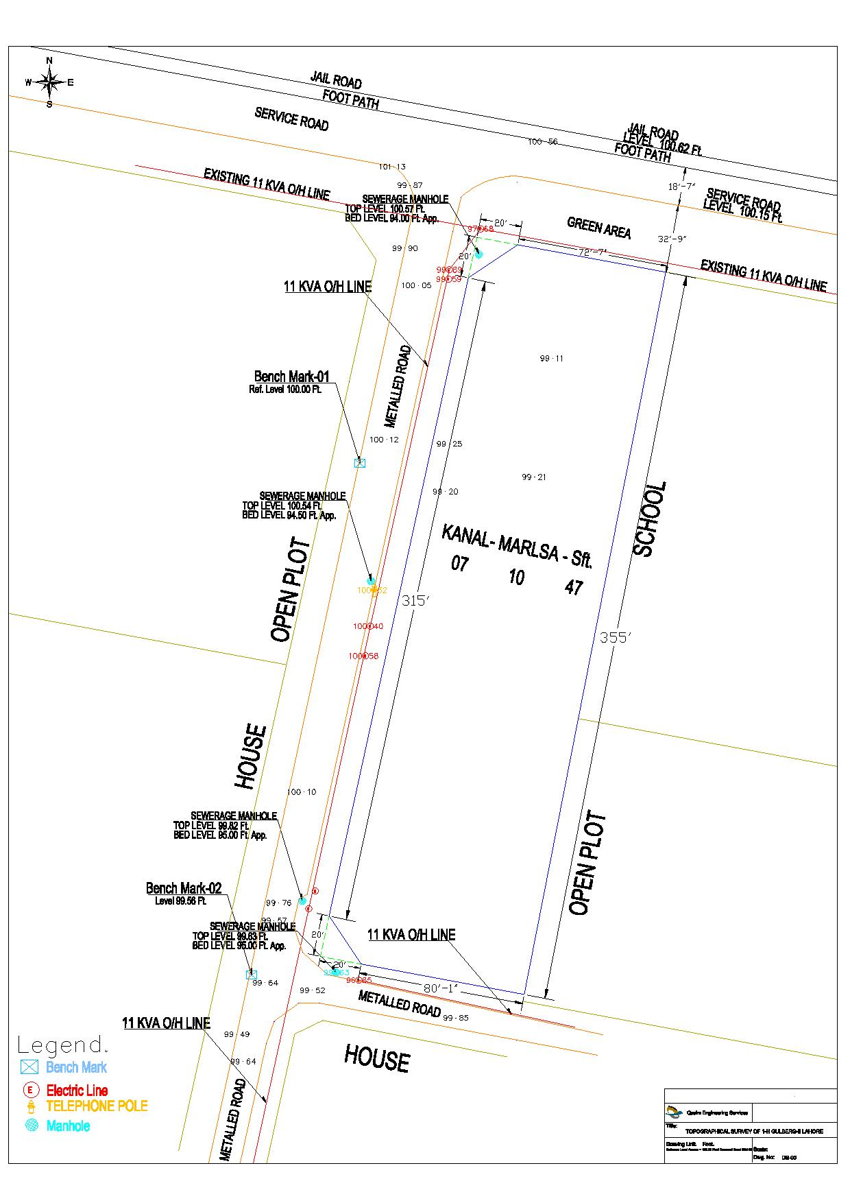
Annexure B – Description of Building Tower – Block A

All the accumulative area mentioned will be the shell and core stage of the building and the Seller is only responsible to provide the above mentioned floor plate, electrical conduits, embedment in concrete slabs, complete facade, single point duct at each floor from building HVAC system, independent lifts, single point power DB at each floor from building main power source & backup generator, plumbing includes clean water single point provision, firefighting points, and complete water drainage system and nothing more along with the allotted car parking area.

Annexure C – Details of Sale Price

Sr. No. | Advance Payment/Payment Milestone | Payment amount | Payment Mode and Date
 | First Advance Payment | PKR 229,101,504/- (Pakistani Rupees Two Hundred Twenty-Nine Million One Hundred One Thousand Five Hundred Four only) paid in following two installments: | -
 |  | - PKR 213,064,399/- (Pakistani Rupees Two Hundred Thirteen Million Sixty-Four Thousand Three Hundred Ninety-Nine only) | Vide cheque No. 00629731 dated December 24, 2019 drawn on Askari Bank Limited
 |  | - PKR 16,037,105/- (Pakistani Rupees Sixteen Million Thirty-Seven Thousand One Hundred Five only) | Vide cheque No. 00629789 dated December 27, 2019 drawn on Askari Bank Limited
 | Second Advance Payment (Signing of Agreement to Sell) | PKR 114,550,752/- (Pakistani Rupees One Hundred Fourteen Million Five Hundred Fifty Thousand Seven Hundred Fifty-Two only) | Vide Cheque No. / Pay Order No. [●], dated [●], drawn on [●]
 | Third Advance Payment (LDA Approval) | PKR 114,550,752/- (Pakistani Rupees One Hundred Fourteen Million Five Hundred Fifty Thousand Seven Hundred Fifty-Two only) | Vide Cheque No. / Pay Order No. [●], dated [●], drawn on [●]
 | [please insert] | [please insert] | Vide Cheque No. / Pay Order No. [●], dated [●], drawn on [●]
 | [please insert] | [please insert] | Vide Cheque No. / Pay Order No. [●], dated [●], drawn on [●]
 | [please insert] | [please insert] | Vide Cheque No. / Pay Order No. [●], dated [●], drawn on [●]
 | [please insert] | [please insert] | Vide Cheque No. / Pay Order No. [●], dated [●], drawn on [●]

Annexure D – List of Common Areas

Annexure E – Car Parking Schedule

